A Study of the Effects of Integrating Computer-Based Practice Problems into the Algebra I Classroom

Al Bierschbach

CET 791
Dakota State University

A Study of the Effects of Integrating Computer-Based Practice Problems into the Algebra I Classroom

Review of the Literature:

Computer use in the teaching and learning of mathematics is being encouraged and research shows that it is beneficial (Manoucherhri, 1999). According to Sylvia Charp, “When properly used, computers can serve as important tools for improving student achievement,” (1999). Students are found to be challenged, engaged, and more independent when using technology (Means et al., 1993). Students enjoy using computers as an aid for math (Kersaint and Chappell, 2001). As a motivational tool, technology positively impacts student attitudes toward learning, self-confidence, and self-esteem (Riley et al., 1996). Computer use can have many positive effects in the learning of mathematics. Not only can it motivate students to learn, but it can also help students improve their achievement.

Statement of the Problem:
This study explores the following question: Does the integration of computer-based practice problems have a positive effect on the achievement of Algebra I students?

Hypothesis:

Integrating online computer-based practice problems has a positive effect on the achievement of Algebra I students as compared to using traditional methods.

Method:

Subjects:

A total of fifty-three students involved in this study in the Spring of 2001. These students were from Madison High School, which is a small rural high school in Madison, SD, with a student population of 535 students. Two Algebra I classes were subjects, chosen by convenience. In this study the two groups will be referred to as the test group and the control group. Each group used the same Algebra I textbook. The control group met from 8:15 a.m. to 9:27 a.m. each day. The test group met from 9:31 to 10:43 each day. The control group was made up of 29 students: 2 sophomores and 27 freshmen. The test group was made of 24 students: 1 junior, 1 sophomore and 22 freshmen.

Role of the Investigator:
The role of the investigator is a participant, as he is also the instructor of the students in the Algebra I classes. In this study, he will be referred to as the instructor.

Design:
The quantitative aspect of the study was a standard T-test, which used a written pretest and posttest comparing two classes of Algebra I. Other quiz scores were also used in the comparison of the two groups. Both groups were given the same instruction on each section of the unit. The test group was given access to online practice pages designed by the instructor, which were password protected. The control group was given traditional written practice problems from the textbook in for an equal amount of time that the test group was given access to the online practice pages. Both the test and control groups were also given traditional written practice problems for independent study. A qualitative aspect of this study compares students’ comments and attitudes towards working with polynomials in both groups.

Instruments:

The students complete six units during the twelve-week trimester period. The study focuses on the third unit during the trimester. The online practice pages are divided into four separate practice quizzes. A sample of the online practice pages appears below.

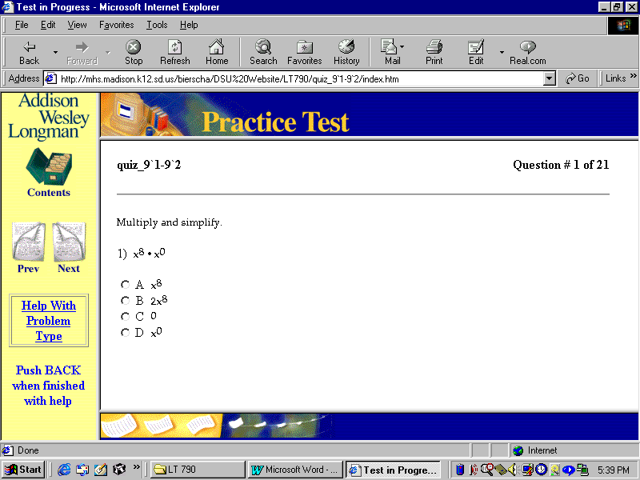

Problem and
Answer
Window
Answer Bar

Students were given a multiple-choice format for each problem. Once a radio button was selected, the answer bar at the bottom of the page would change to either “Correct! Good Job.”, or “Sorry, the answer you chose is not correct. Try again.” The page does not automatically advance once the correct answer is given, or after a certain number of attempts to get the correct answer. To advance to the next problem, a student would push on the “Next” icon on the left side of the page. A student could also go to previous problems by pushing the “Prev” icon. To get to a different practice quiz while taking one of the practice quizzes, the student would push on the “Contents” icon on the left side. A help section is also available if a student selects the “Help With Problem Type” hyperlink. The help screen opens in the problem and answer window. A student can read a short description and see examples of a specific problem type. When finished with the practice quiz, the student can either go to the contents page to select another quiz or can exit the browser.
The study uses various scores to compare the test group with the control group. Scores used as a comparison included:
- Previous class average from the first two units of the trimester
- Unit pretest
- Three quizzes from the unit
- Unit posttest
The publisher of the textbook wrote the quizzes. The instructor, using problems similar to the exercises that were assigned in the textbook, wrote the pretest and posttest. A copy of each test and quiz appears below.

Chapter 9 Pretest Algebra I Name____________________

Multiply.
1. x²x³ 2. (2xy)(3xy²) 3. (4xy²)²

Simplify.
- 10xy² 5. x⁻⁵
5x²y

Put into scientific notation.
6. 25,000,000,000 7. 0.00000712

Put the following polynomial in descending order of x.
- 4x² – 2x³ + x⁴ –5 + x

Add or subtract.
9. (6x² + 3x – 4) + (2x² + 5x + 1) 10. (6x² + 3x – 4) – (2x² – 5x + 2)

Multiply.
11. 4x(3x + 5) 12. (x + 2)(x + 3) 13. (x – 3)²

Chapter 9 Quiz 9.1-9.2 Name___________________

Simplify.
1. (x³y⁴)(x²y³) 2. (r³n⁵)(-5r³n⁵)

3. (-4x²y³z)(3xyz²) 4. (x⁵)⁴

5. (-5x⁴y²)³ 6. (5y²w⁴) + 2(yw²)⁴

Simplify. Assume no denominator is equal to zero.
- y⁹ 8. r⁶n⁻⁷
y⁶ r⁴n²

9. 6x⁵y⁷w³ 10. (4x²y³)⁰
8x²y¹⁰w³ 8x³

Chapter 9 Quiz 9.3-9.4 Name_________________________

Express each number in scientific notation.
1. 57,600 2. 0.0000061

- Write 6.4871 x 10⁻³ in decimal notation.

Evaluate. Express each result in scientific notation.
4. 7.2 x 10⁻⁵ 5. (3.5 x 10⁶)(8.2 x 10³)
  - x 10²

Find the degree of each polynomial.
6. 5a – 2b² + 1 7. 24xy – xy³ + x²

Arrange the terms of each polynomial so that the powers of x are in descending order.
8. 4x² – 3x³ + 2x + 12 9. 5x³y + 3xy⁴ – x²y³ + y⁴

Arrange the terms of each polynomial so that the powers of x are in ascending order.
10. –3 + x² + 4x

Chapter 9 Quiz 9.5-9.6 Name_________________________

Find each sum or difference.
1. (-2x² + x + 6) + (5x² – 4x – 2) 2. (5a + 9b) – (2a + 4b)

- 3a² – 7a + 4
(–) a² + 14a – 4

Simplify.
4. 3xy(2x² + 5xy – 7y²)

5. 5c²(c + 10) – 4c(2c² – 6c + 1)

Algebra I Chapter 9 Test Name__________________

Multiply.
1. x(x²)(x⁷) 2. (-5a²b)(3a⁴)

Simplify. Assume that no denominator is equal to zero.
3. (3pq²)² 4. 12n⁵
36n

Simplify, leaving no negative exponents.
5. c⁰ 6. 48r¹²s⁸
c⁻³ 16r¹⁴s⁶

Express in scientific notation.
7. 41,000,000 8. 0.00000000814

Evaluate. Express answer in scientific notation.
9. (8.3 x 10²)(9.1 x 10⁻⁷) 10. 1.68 x 10⁴
  - x 10⁻⁴

Find the degree of the polynomial.
- 24xy – xy³ + x²

Put the following polynomial in descending order of x.
- x² + x⁴ – 2x – x³

Add or subtract.
13. a² + ab – 3b² 14. 5e² – e – 7
(+) 4a² – ab + b² (–) –2e² + 3e + 4

15. (5x² – x – 7) + (2x² + 3x + 4) 16. (7x² + x + 1) – (3x² – 4x – 3)

Multiply.
17. 6(4a + 3) 18. –3u(8u² – 3u + 1)

Multiply and simplify, if necessary.
19. 5m(11m² – 4n) 20. 6t(2t – 3) – 5(2t² + 9t – 3)

21. (x + 2)(x + 7) 22. (x – 10)(x + 2)

23. (3t + 2q)(7t – 9q) 24. (2x – 3)(2x + 3)

25. (3k + 2h)² 26. (4u – 5)²

27. (2 + 3c)(4 + 6c + 9c²) 28. 9m² – 12m + 4
(x) 3m + 2

Procedure:

Both groups used the same curriculum and textbooks, and were given the same textbook assignments, pretest, and posttest. The students in the test group were given 15-20 minutes to work with the online practice problems in the classroom after the completion of the 2nd, 4th, 6th and 8th section of the unit. The test group students worked with the online practice problems before they were given a quiz or the posttest. During the class time that the test group used for the online practice problems, the control group was given independent practice time to work on their homework assignments from the textbook. The instructor did not inform either group that they were part of a study and the instructor did not assist the students during either the pretest or the posttest.
Analysis:
In the following graph, pretest and posttest scores are compared from each group.
In paired T-tests, both the test group and the control group improved from their pretest to posttest. In the test group, the pretest average was 10.0% and the posttest average was 87.5%, which was a gain of 77.5%. In the control group, the pretest average was 16.8% and the posttest average was 88.2%, which was a gain of 71.4%. Both gains are statistically significant (p = 0.000). The control group and the test group were compared using a two sample T-test of the pretest scores, which showed the groups were not statistically different from each other at a 0.05 level. However, the groups were very close statistically to being different from teach other (p = 0.07) and by observation of the groups by the instructor gave strong consideration that the groups were different by looking at the previous class average, looking at all of the scores during the study, and observing the motivation of the students prior to and during the study.
The next graph compares six different scores. It displays how going into the unit, the control group scored 6.6% higher on average on their assignments compared to the test group previous to the study. The pretest displays a similar difference (6.8%), but there is only a 0.7% difference in the class average on the posttest. Thus the class average of the test group gained 6.1% compared to the control group. The test group actually outperformed the control group on the first quiz, but on the other quizzes the two groups returned to the prior norm of the control group outperforming the test group by about 7%. When it came to the posttest, the both groups showed significant gains as compared to the pretest, but the test group showed a high percentage gain (77.5%) from
the pretest to the posttest than the control group (71.4%). With the same material covered in a similar manner in both classes, these results show that the computer-based practice problems had a positive impact on the achievement of the test group.
The use of statistical averages was not the only method of analyzing whether the computer-based practice problems had a positive effect on the students. Comments that the test group students made about the pages were also noted. One student remarked that working with the pages was, “Much more fun than doing homework problems.” Other students made comments similar to “Oh, now I understand how to do this.” These comments exhibit that the students were more motivated to learn the topics in the unit after working with the computer-based practice problems.
The students were not asked to work with the practice pages at home, but some students did reveal that they used the practice pages at home. The students did have some difficulty logging-in on the computers at the school, but the students who worked with these pages at home did not have any difficulty logging-in. Students with various levels of ability voluntarily worked with these pages at home, without being asked. One student, who rarely worked on Algebra outside of the classroom, reported that he used the online practice pages at home. Working with the practice pages at home without being asked demonstrates the motivational factor of computers in the educational process.
In the control group, the students had to be motivated to stay on task with their traditional homework problems. In the test group, the students worked with the computer-based practice problems without needing to be motivated to keep working. On days that the students did not work with the online practice problems, many students asked if they could use the pages.
In the control group, there were no distinguishable positive comments towards learning polynomials. In the test group, students made many positive comments towards learning polynomials. One student made the comment, “I like working with this stuff (polynomials), it is a lot better than graphing.” Another student made the comment, “Once you learn the basic rules, this is really easy.” Another student said, “All of these rules are really confusing, but using the computer makes it easier to understand.” These comments show that the students had an increase in self-confidence, which allowed the students to master learning the concept of polynomials much more easily.
In summary, the students in the test group did gain from the computer-based practice pages used in this study. The students in the test group showed more gain from pretest to posttest as compared to the control group. The test group class average gained 6.1% from the pretest to the posttest compared to the control group. More importantly, the students in the test group were more motivated to learn the concept of polynomials than the control group. Some students, who normally do not complete much work outside of the classroom, voluntarily worked with the practice pages outside of the classroom. Thus, integrating online computer-based practice problems did have a positive effect on the achievement of Algebra I students.

Further Development of the Research:
Research in this area needs to be continued to study the effects of using similar practice pages for an entire term of a class, instead of one unit. Data should be collected to see if the novelty effect of using online practice pages was a causing factor in motivating students after using the software over a longer period of time. Another factor that need to be researched is the time of day that the students are studied. Achievement and motivation can change depending upon the time of day the class is offered. Classes that are chosen randomly rather than by convenience should also be studied.

References

Charp, S. (1999). Classrooms of tomorrow. T.H.E. Journal, 26, 4.

Kersaint, G., & Chappell, M. (2001). Capturing students’ interests: A quest to discover
mathematics potential. Teaching Children Mathematics, 7, 512-517.

Manoucherhri, A. (1999). Computer and school mathematics reform: Implications for
mathematics teacher education. The Journal of Computers in Mathematics and Science
Teaching, 18, 31-48.

Means, Blando, Olson, Middleton, Remz, & Zorfass. (1993). Using technology to
support educational reform. [Online]. Available: http://www.ed.gov/pubs/
EdReformStudies/TechReforms, June 20, 2001.

Riley, R., Kunin, M., Smith, M., & Roberts, L. (1996). Getting America’s students read
for the twenty-first century. [Online]. Available: http://www.ed.gov/Technology/Plan
/NatTechPlan/benefits.html, June 20, 2001.

